Discussion Assignment 2
Is the price change of the stock $10 to $15 from January 1st to March 31st a straight line?
Linear equation representing price change in each segment can be determined as follows:
January to February:
Linear equation has the form $f(t)=m_{1}t+c$
$m_{1}=\frac{∆ in price}{∆ in time}=\frac{12-10}{31-1}=\frac{2}{30}=\frac{1}{15}$
To find the value of $c$, $10=\frac{1}{15}\left(1\right)+c$.
$c=\frac{149}{15}$
Therefore, the linear equation for the first segment will be $f\left(t\right)=\frac{1}{15}t+\frac{149}{15}$
February to March:
Linear equation has the form $f(t)=m_{2}t+c$
$m_{2}=\frac{∆ in price}{∆ in time}=\frac{9-12}{28-1}=\frac{-3}{27}=-\frac{1}{9}$
To find the value of $c$, $12=-\frac{1}{9}\left(1\right)+c$.
$c=\frac{109}{9}$
Therefore, the linear equation for the second segment will be $f\left(t\right)=-\frac{1}{9}t+\frac{109}{9}$
March to April:
Linear equation has the form $f(t)=m_{3}t+c$
$m_{3}=\frac{∆ in price}{∆ in time}=\frac{15-9}{31-1}=\frac{6}{30}=\frac{1}{5}$
To find the value of $c$, $9=\frac{1}{5}\left(1\right)+c$.
$c=\frac{44}{5}$
Therefore, the linear equation for the third segment will be $f\left(t\right)=\frac{1}{5}t+\frac{44}{5}$
Graph of representing the linear equations of the three segments:
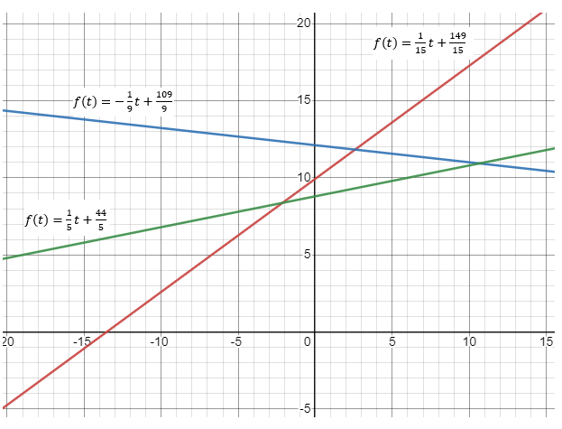
Based on the graph above, it is evident that the price change of the stock $10 to $15 from January 1st to March 31st is a straight line.
This graph shows the approximate stock price movement over the three-month period using linear segments. However, it is it should be noted that this is a simplified model and may not capture all the intricacies of daily price fluctuations since it offers a basic approximation based on the given data and linear interpolation between the known points.
When it comes to predicting, this simplified model may provide a rough approximation, without considering other factors such as market trends, news events, or external influences that have s significant influence on stock prices. Therefore, there is a need for advanced models and analysis to accurately predict future prices of stock.
Graph of price movement
$f\left(t\right)=\frac{1}{15}t+\frac{149}{15}$ {0 < x < 2}, $f\left(t\right)=-\frac{1}{9}t+\frac{109}{9}$ {2 < x < 5}, $f\left(t\right)=\frac{1}{5}t+\frac{44}{5}$ {5 < x < 8}
